**Chapter 2 Summary**

**THE ROLE OF INFORMATION SYSTEMS IN BUSINESS**

**1. Strategic Enhancement of Success Measures:**

* **Enhancing Organizational Success:** Information systems play a pivotal role in helping businesses enhance their success measures, whether it's profitability, market share, or customer satisfaction.
* **Strategic Alignment:** Businesses strategically align their information systems with organizational objectives to streamline operations, boost efficiency, and achieve competitive advantage.

**2. Streamlining Value Chain Activities:**

* **Optimizing Operations:** Information systems streamline the value chain, optimizing activities from production to delivery.
* **Efficient Resource Management:** Businesses employ information systems to manage resources effectively, ensuring cost efficiency and timely delivery of products or services.

**3. Competitive Strategy Implementation:**

* **Adapting to Competitive Forces:** Information systems aid businesses in understanding and adapting to competitive forces in their industry, enabling effective responses to market demands and challenges.
* **Data-Driven Decision Making:** Analysing market data through information systems allows businesses to make data-driven decisions, adapting their strategies based on real-time insights.

**4. Enhancing Communication and Collaboration:**

* **Internal Communication:** Information systems facilitate seamless communication within organizations. Employees can share information, collaborate on projects, and make informed decisions collectively.
* **External Communication:** Businesses use information systems for customer relationship management (CRM) and supplier interactions, enhancing communication with external stakeholders.

**5. Customer and Supplier Connectivity:**

* **Customer Interaction:** Information systems enable businesses to connect with customers through online platforms, enhancing the customer experience, providing personalized services, and gathering valuable feedback.
* **Supply Chain Management:** Businesses use information systems to manage supplier relationships, optimize supply chains, and ensure the timely availability of raw materials or products.

**6. Informed Decision-Making:**

* **Data Analysis:** Information systems collect and analyse vast amounts of data, allowing businesses to gain insights into market trends, customer preferences, and operational efficiencies.
* **Predictive Analytics:** Advanced information systems utilize predictive analytics, forecasting future trends and customer behaviour, empowering businesses to make proactive decisions.

**7. Future-Focused Innovation:**

* **Continuous Improvement:** Businesses invest in information systems to stay ahead in the competitive landscape, continuously improving their processes, services, and products based on technological advancements and customer needs.
* **Agility and Adaptability:** Information systems provide businesses with the agility to adapt to changing market dynamics, ensuring they remain innovative and responsive to emerging challenges and opportunities.

In summary, the role of information systems in business is multifaceted, encompassing strategic alignment, operational optimization, effective communication, customer and supplier connectivity, data-driven decision-making, and continuous innovation. By leveraging information systems effectively, businesses can enhance their competitive edge, achieve sustainable growth, and navigate the complexities of the modern business landscape.

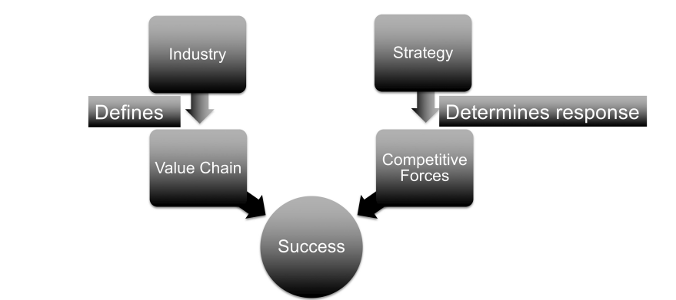

**1. Low-Cost Strategy:**

* **Operational Efficiency:** Information systems play a crucial role in achieving operational efficiency, reducing costs, and optimizing processes. Businesses employing a low-cost strategy rely on information systems to streamline supply chains, manage inventory, and minimize overheads.
* **Data Analytics:** Utilizing data analytics, these systems help in cost analysis, identifying areas for cost-cutting, and ensuring cost-effectiveness in production and distribution.

**2. Differentiation Strategy:**

* **Product Innovation:** Information systems facilitate innovation by enabling efficient communication and collaboration among teams. Companies employing a differentiation strategy leverage these systems for product research, design, and development, ensuring their offerings stand out in the market.
* **Customer Relationship Management (CRM):** Information systems support personalized customer service. They collect and analyze customer data, enabling businesses to tailor their offerings to individual preferences and provide exceptional customer experiences.

**3. Niche Strategy:**

* **Targeted Marketing:** Information systems aid businesses in understanding the unique needs of niche markets. They enable targeted marketing campaigns, ensuring that products or services align with the specific requirements of the chosen market segment.
* **Customization:** Information systems allow for customization of products or services based on niche market demands. Businesses can adapt their offerings swiftly, catering to the specialized needs of their target audience.

**4. Competitive Response Strategies:**

* **Market Analysis:** Information systems provide real-time market analysis, allowing businesses to monitor competitors' moves, pricing strategies, and customer preferences. This data informs strategic decisions, enabling businesses to respond effectively to competitive pressures.
* **Agile Decision-Making:** Information systems empower businesses to make agile decisions in response to market dynamics. Rapid access to market data and predictive analytics ensures timely responses, helping companies maintain their competitive edge.

**5. Strategy Alignment:**

* **Strategic Integration:** Information systems align with organizational strategies, ensuring that technology initiatives complement the chosen business strategy. Whether it's cost reduction, differentiation, or niche focus, information systems are tailored to support and enhance the chosen strategic direction.
* **Performance Metrics:** These systems provide performance metrics and key performance indicators (KPIs) aligned with the business strategy. Continuous monitoring allows businesses to assess their progress, identify areas of improvement, and adapt strategies as needed.

**6. Adapting to Changing Strategies:**

* **Flexibility:** Information systems should be flexible and scalable, allowing businesses to adapt quickly to shifts in strategies. Whether a business pivots from a low-cost to a differentiation strategy or refines its niche focus, information systems must be adaptable to support evolving business objectives.
* **Strategic Innovation:** Information systems drive strategic innovation by facilitating brainstorming, idea generation, and feasibility analysis. They enable businesses to explore new avenues, experiment with novel approaches, and innovate in alignment with their strategic goals.

In summary, information systems serve as the backbone of business strategies, enabling organizations to implement low-cost, differentiation, or niche strategies effectively. By leveraging these systems, businesses gain a competitive edge, respond strategically to market pressures, innovate in line with their objectives, and ensure alignment between technology initiatives and overall business goals.

**1. Rivalry Among Existing Competitors:**

* **Market Analysis:** Information systems aid in market research, enabling businesses to understand customer preferences and competitors' offerings. Analyzing this data helps companies tailor their products or services to gain a competitive edge.
* **Customer Relationship Management (CRM):** Information systems facilitate CRM by tracking customer interactions, feedback, and preferences. This data helps in improving customer engagement strategies, ensuring loyalty, and countering competitor moves effectively.

*Impact of the Web:* The internet provides new avenues for competition. Positive online reviews, social media presence, and efficient online services influence customer choices, creating new competitive battlegrounds. Companies must adapt their strategies to these digital platforms to stay competitive.

**2. Bargaining Power of Customers:**

* **Customization:** Information systems enable customized offerings, tailoring products/services based on individual customer needs. This customization enhances customer satisfaction, making them less likely to switch to competitors.
* **Loyalty Programs:** Information systems manage loyalty programs effectively, offering incentives beyond just price. Customer data analysis ensures personalized rewards, strengthening customer loyalty.

*Impact of the Web:* The internet enhances customer bargaining power by providing extensive options. Companies can mitigate this by creating customer loyalty through efficient online services, personalized interactions, and loyalty programs. Switching costs, facilitated by information systems, discourage customers from easily switching to competitors.

**3. Bargaining Power of Suppliers:**

* **Supply Chain Management:** Information systems optimize supply chains, reducing costs and ensuring timely deliveries. Efficient inventory management and demand forecasting enhance negotiations with suppliers, ensuring favorable terms.
* **Partnerships and Alliances:** Information systems facilitate alliances with suppliers. Integrated systems streamline communication and transactions, creating mutually beneficial partnerships.

*Impact of the Web:* The internet offers access to global suppliers, reducing geographical constraints. Effective supplier relationship management systems ensure seamless collaborations. However, technological integration with suppliers creates a barrier, deterring potential new entrants.

**4. Threat of New Entrants:**

* **Technological Barriers:** Information systems create technological barriers to entry. Advanced systems and online platforms expected by customers become expensive entry requirements, deterring new competitors.
* **Online Presence:** The web offers global visibility. A strong online presence and efficient e-commerce platforms act as entry barriers, as newcomers struggle to match established businesses' online reach and capabilities.

**5. Threat of Substitute Products or Services:**

* **Innovation:** Information systems foster innovation, helping businesses develop new products or services. Staying ahead in innovation creates a defence against substitute products, ensuring continued customer relevance.
* **Digital Substitutes:** Technology enables digital substitutes. Businesses must evolve to provide digital alternatives to traditional offerings, ensuring customers find value in their products or services despite emerging substitutes.

*Impact of the Web:* The internet accelerates digital substitutes. Companies must adapt by offering unique digital experiences, ensuring customer loyalty despite the availability of online alternatives.

Understanding these competitive forces and leveraging information systems strategically empowers businesses to navigate challenges, maintain customer loyalty, and sustain a competitive advantage in the digital age. Employees who comprehend this intersection are invaluable assets to organizations, contributing significantly to strategic decision-making and long-term success.

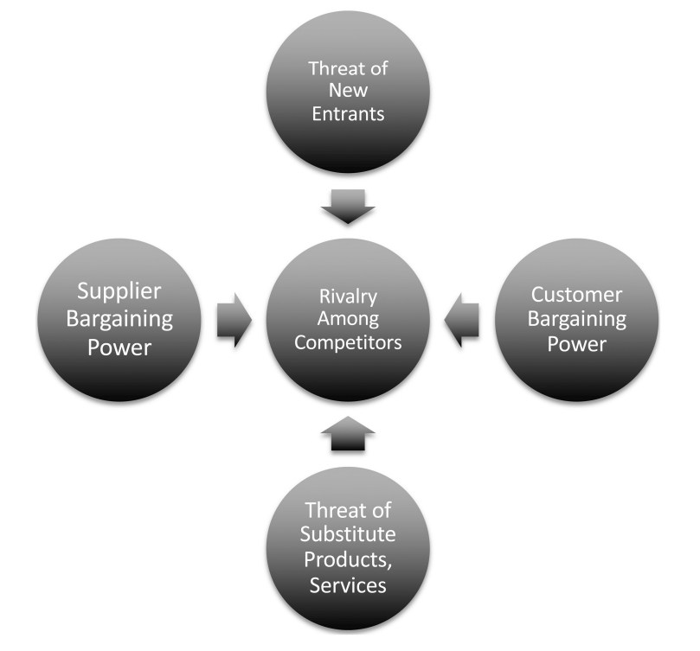

**Understanding the Value Chain:** The value chain concept breaks down the various activities within an organization, from raw material acquisition to the delivery of the final product or service. These activities can be categorized into primary activities, which are directly involved in the creation and delivery of the product, and support activities, which facilitate the primary activities. Each stage represents an opportunity for optimization and innovation.

**1. Inputs and Outputs Analysis:**

* **Inputs:** Identify the resources required for each stage - materials, labor, information, technology.
* **Outputs:** Determine the end products or services. Understand their value to customers.

**2. Applying Information Systems in the Value Chain:**

* **Admitting (or Intake):** Implement electronic health records (EHR) systems. Use data analytics for efficient patient admissions and personalized care plans.
* **Diagnosis:** Utilize AI-powered diagnostic tools for faster and accurate results. Access online medical databases for research and real-time consultation.
* **Treatment:** Employ electronic prescribing systems to prevent drug interactions. Implement robotics in surgery for precision and efficiency.
* **Patient Care and Therapy:** Implement telemedicine solutions for remote consultations. Utilize shared databases for seamless communication among healthcare professionals.
* **Discharge:** Automate billing processes to reduce errors. Provide patients with electronic health summaries for post-hospital care. Utilize mobile apps for follow-up appointments and medication reminders.

**Strategic Questions for Information Systems Implementation:**

1. **Cost Optimization:** How can information systems streamline processes, reducing costs without compromising quality?
2. **Value Enhancement:** In what ways can information systems enhance the value of the product or service? This could involve personalization, efficiency, or additional features.
3. **Communication Improvement:** How can information systems improve communication between stages? Integrated databases, real-time updates, and collaborative platforms can enhance coordination.

**Examples from Other Industries:**

* **Education:** Learning management systems (LMS) optimize teaching processes, facilitate remote learning, and provide personalized education plans.
* **Shipping and Logistics:** GPS tracking, RFID systems, and route optimization algorithms enhance shipment visibility, reduce transit times, and improve inventory management.

**Strategic Thinking and Information Systems:** Understanding the value chain equips employees to identify critical areas where information systems can make a difference. By asking strategic questions and envisioning innovative solutions, professionals can drive organizational growth, customer satisfaction, and competitive advantage. Organizations thrive when their employees recognize these opportunities, ensuring the seamless integration of information systems into their strategic framework.

